- Compare the numbers: >, <, =
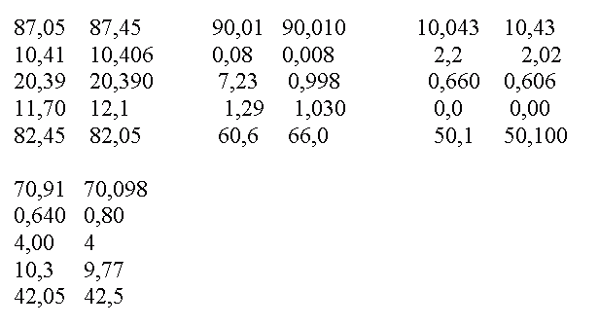
- Round the result off to one decimal number:

3,251 64,78 0,780 0,962 15,971 0,955 0,043 0,75 0,450

- Round off the decimal numbers:

94,47 39,80 179,53 0,62 0,0998 0,511 2,490 99,7 199,8

