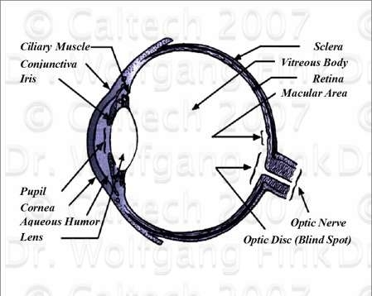
http://autonomy.caltech.edu/biomedicine/images/simeye1.jpg

