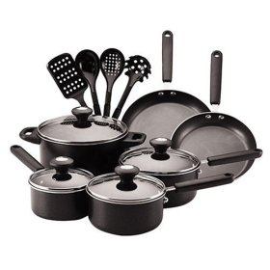 apron

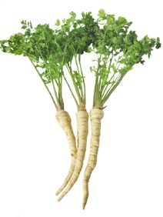 potatoes

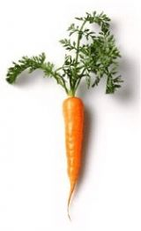 onion

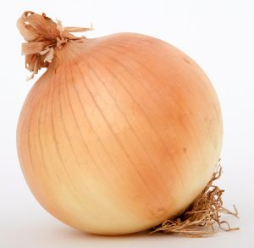 parsley

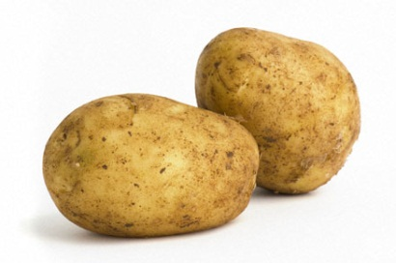 dishes

[](http://images.google.com/imgres?q=z%C3%A1st%C4%9Bra+na+va%C5%99en%C3%AD&hl=cs&gbv=2&biw=1440&bih=688&tbm=isch&tbnid=Ti4HCSHlo6vKaM:&imgrefurl=http://www.homefashion.cz/zastera-na-vareni-mele/d-71014/&docid=tv9xlu8vg66q6M&imgurl=http://www.homefashion.cz/fotocache/bigorig/10MEL07402D43.jpg&w=571&h=800&ei=D7ngTsviIMudOuazgf4J&zoom=1) carrot