Obrázek vejce:
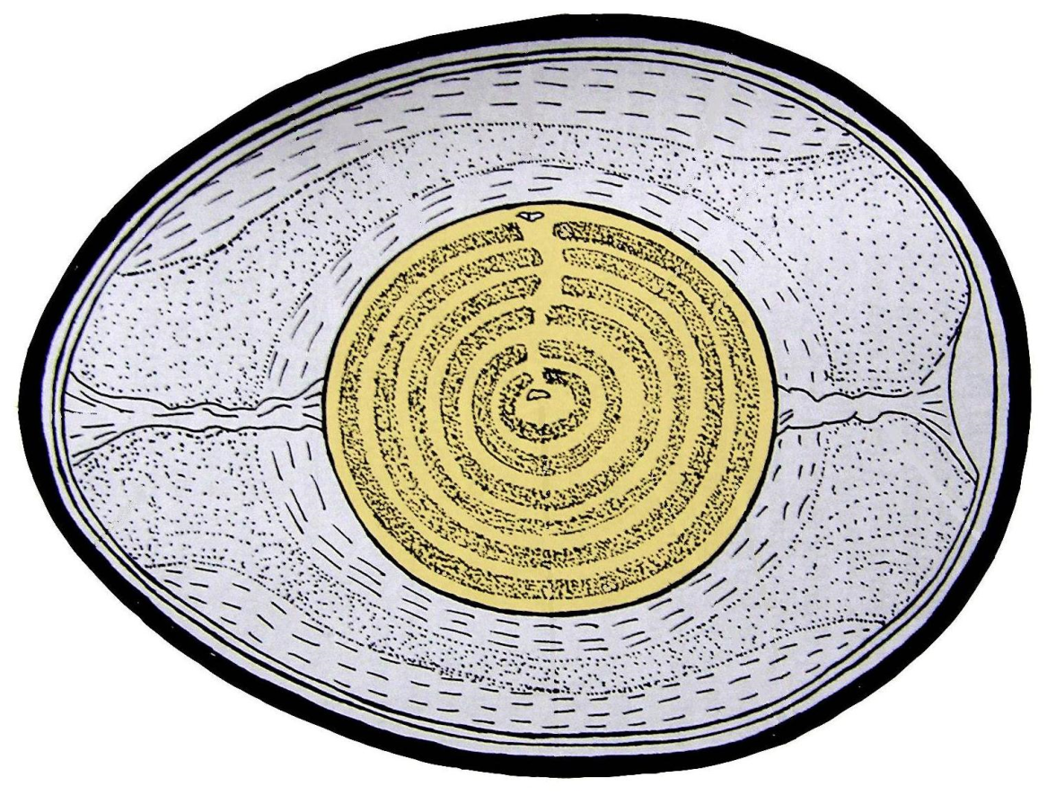
http://82.114.195.35:90/Vyuka/Ka%C4%8D%C3%ADrkov%C3%A1%20Jarmila/2.ro%C4%8Dn%C3%ADk/09%20Strunatci/5%20Pt%C3%A1ci/stavba%20pta%C4%8D%C3%ADho%20vejce.JPG

paper membrane | yolk | egg white
eggshell | loop | embryo

žloutek
bílek

skořápka
poutko
zárodek
papírová blána

